
LANDLORD/HOMEOWNER
To confirm the validity of the Registered Gas Engineer please contact Gas Safe on 0800 408 5577 or www.gassaferegister.co.uk
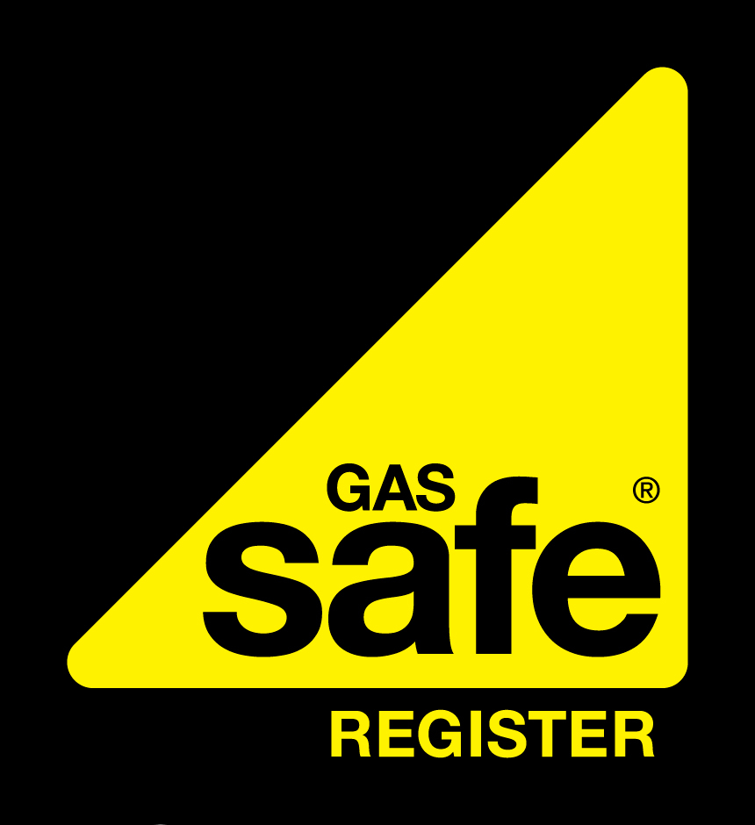
APPLIANCE SPECIFICS
 | Appliance 1 |  | Appliance 2 |  | Appliance 3 |  | Appliance 4
Location of appliance
Appliance type
Appliance make
Appliance model
Type of flue/outlet (OF/RS/FL)
Working pressure in mbar or heat input kW/Btu/h
Are safety devices working? (Yes/No/NA)
FLUE TESTS
Spillage (Pass/Fail/NA)

Smoke Pellet (Flue Flow) (Pass/Fail/NA)
Adequate termination (Yes/No/NA)
Visual condition (Pass/Fail/NA)
INSPECTION
Has this appliance been inspected (Yes /No)
Is this appliance owned by the Landlord (Yes/No)
Is there adequate ventilation? (Yes/No)
Has the appliance been serviced? (Yes/No)
Combustion performance reading CO:CO2 ratio / Co2 / CO
Is this appliance safe to use? (Y / N)
If No – has a warning advice notice been issued? (Y / N)
DEFECT (s) DETECTED
Appliance 1  Engineer Name: Anthony Walters Gas Safe ID Card No: 2360056  Company Name: TW Plumbing Services Ltd  Address: 4 Gorings Mead, Horsham, West Sussex, RH13 5BP Tel. No: 01403 251144 |  | Appliance 2  Engineer Name: Anthony Walters Gas Safe ID Card No: 2360056  Company Name: TW Plumbing Services Ltd  Address: 4 Gorings Mead, Horsham, West Sussex, RH13 5BP Tel. No: 01403 251144 |  | Appliance 3  Engineer Name: Anthony Walters Gas Safe ID Card No: 2360056  Company Name: TW Plumbing Services Ltd  Address: 4 Gorings Mead, Horsham, West Sussex, RH13 5BP Tel. No: 01403 251144 |  | Appliance 4  Engineer Name: Anthony Walters Gas Safe ID Card No: 2360056  Company Name: TW Plumbing Services Ltd  Address: 4 Gorings Mead, Horsham, West Sussex, RH13 5BP Tel. No: 01403 251144
REMEDIAL WORK UNDERTAKEN
Appliance 1  Engineer Name: Anthony Walters Gas Safe ID Card No: 2360056  Company Name: TW Plumbing Services Ltd  Address: 4 Gorings Mead, Horsham, West Sussex, RH13 5BP Tel. No: 01403 251144 |  | Appliance 2  Engineer Name: Anthony Walters Gas Safe ID Card No: 2360056  Company Name: TW Plumbing Services Ltd  Address: 4 Gorings Mead, Horsham, West Sussex, RH13 5BP Tel. No: 01403 251144 |  | Appliance 3  Engineer Name: Anthony Walters Gas Safe ID Card No: 2360056  Company Name: TW Plumbing Services Ltd  Address: 4 Gorings Mead, Horsham, West Sussex, RH13 5BP Tel. No: 01403 251144 |  | Appliance 4  Engineer Name: Anthony Walters Gas Safe ID Card No: 2360056  Company Name: TW Plumbing Services Ltd  Address: 4 Gorings Mead, Horsham, West Sussex, RH13 5BP Tel. No: 01403 251144
Customer Signature: |  |  |  | Registered Engineer Signature:
Print Name: |  |  |  | Print Name:
Date: |  |  |  | Date:
THE NEXT GAS SAFETY CHECK MUST BE COMPLETED WITHIN THE NEXT 12 MONTHS

COMPANY NAME  Gas Safe Reg No: 000000  W: …………… E: ………………  Job Number: |  | INSPECTION ADDRESS |  |  |  |  |  | AGENT/LANDLORD DETAILS (if different)
 |  | Name: |  |  |  |  |  | Name/Company:
 |  | Address: |  |  |  |  |  | Address:
 |  | Tel. No: |  |  |  |  |  | Tel. No:
 |  | Is accommodation rented? YES |  |  | NO |  |  | No. of Appliances tested:
GAS INSTALLATION PIPEWORK |  |  | Emergency Control Valve Accessible? (Y / N)
Is Equipotential Bonding satisfactory?(Y/N) |  | Visual Inspection satisfactory? (Y / N) |  |  |  |  |  | Gas Tightness Test satisfactory? (Y / N)
This form allows for the recording of results of checks as defined by the Gas Safety (Installation and Use) Regulations. Information recorded on this form does not confirm that the installation was installed by a Gas Safe registered business or that the installation complies with relevant Building Regulations. Chimney/flue/outlets were visually checked for adequate evacuation of combustion products. A detailed internal inspection has not been undertaken.

